**Creating Well-Structured .Output for API Clients Using Postman to Get Weather Report**

**Project Aim**

The aim of a project involving Postman, typically, revolves around API development, testing, and documentation. Postman is a popular API testing and development tool that helps streamline the process of building and managing APIs.

**Github Link:**

https://github.com/Himadri650/Postman-API

**I used following :**

* Postman
* Endpoint URL(<https://samples.openweathermap.org/data/2.5/weather?q=London,uk&appid=b6907d289e10d714a6e88b30761fae22>)

**Steps :**

Step-1:

First open Postman

Step-2:

Then I click on “+” sign to create a collection

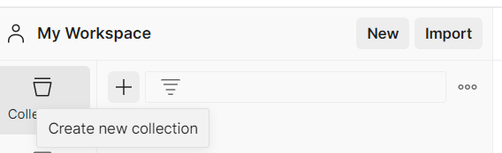

Step-3:

Then I click on Blank Collection

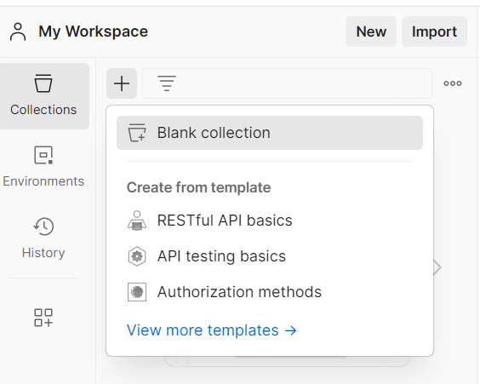

Step-4:

Then I rename it as OpenWeatherMap-Api_Test

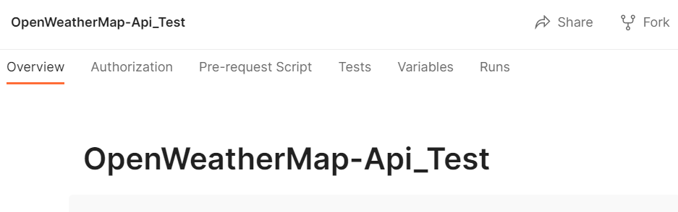

Step-5:

After that I click on three dots then click on Add request

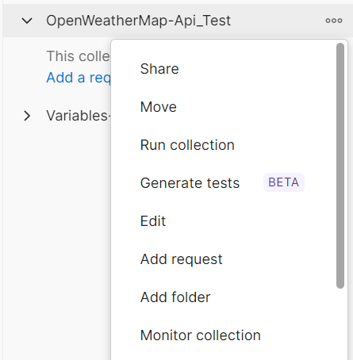

Step-6:

Then I rename it as OpenWeather-Get



Step-7:

Then I select Get method and I paste the url

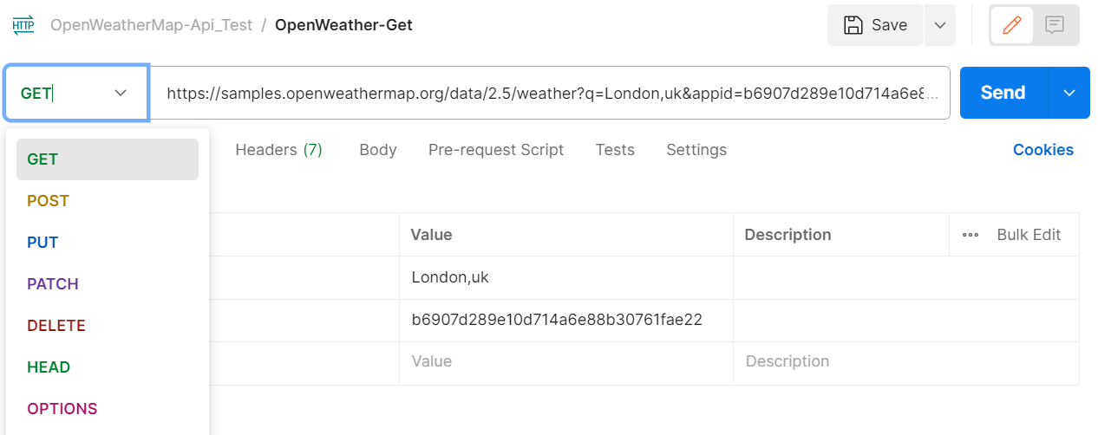

Step-8:

Then I click on send

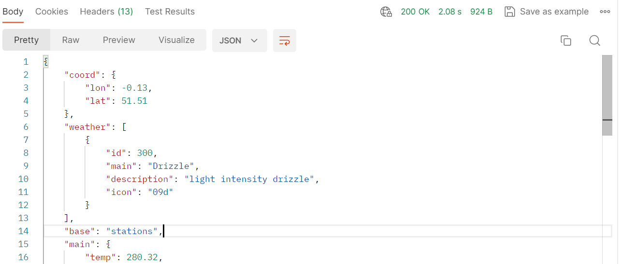

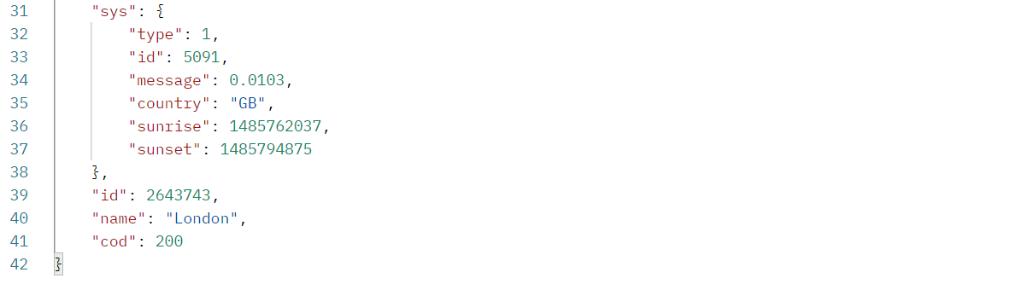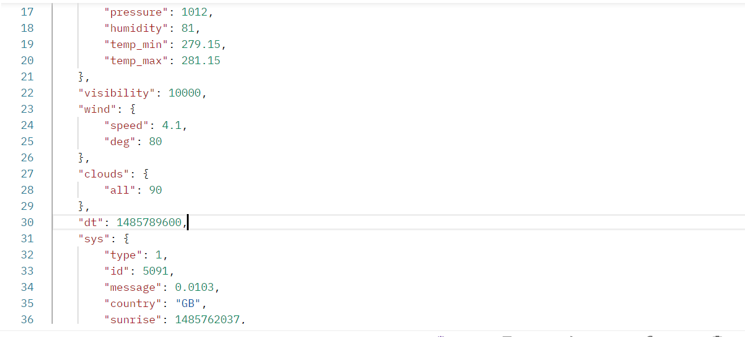

Step-9:

Then I click on collection



Step-10:

Then I click on variables to create a collection variable

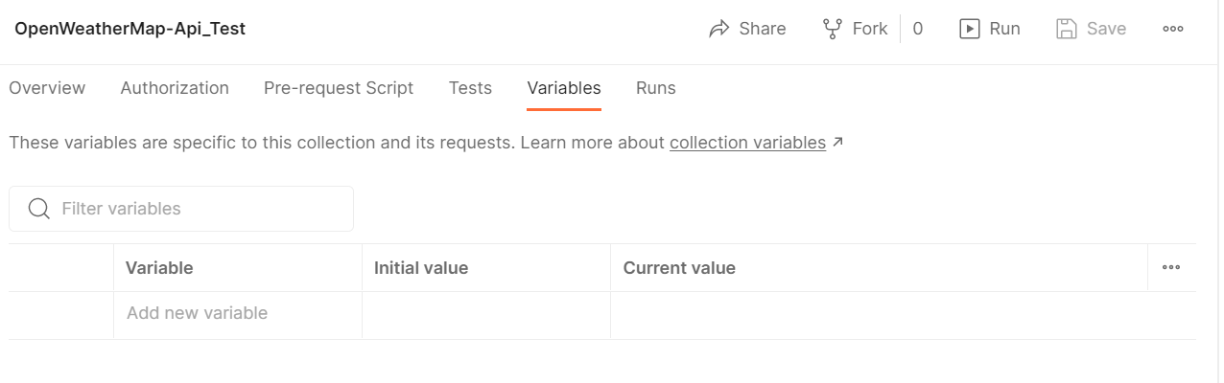

Step-11:

Then I give a variable name and initial value and current value

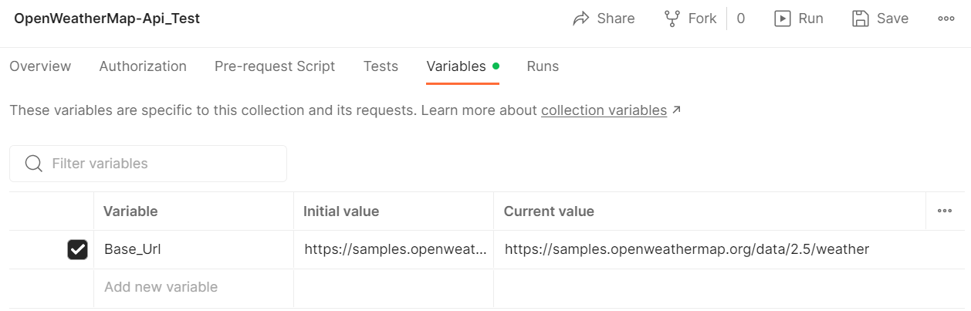

Step-12:

Then I save it



Step-13:

Here I select Base_Url variable inside request within double curly braces

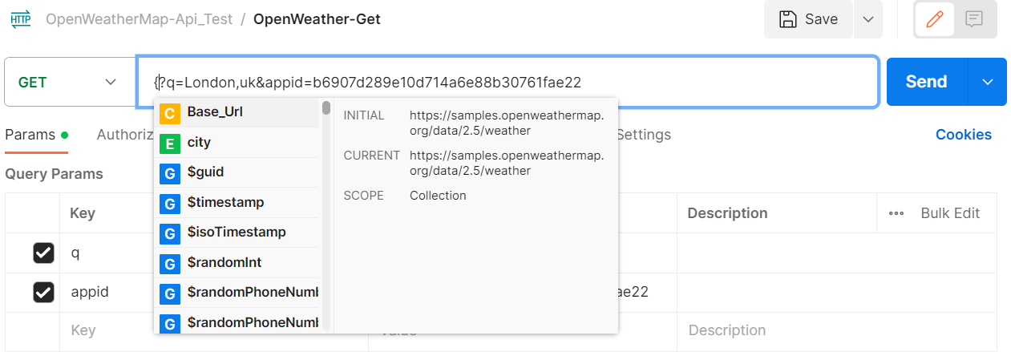

Step-14:

Then I click on Environments to create a environment variable

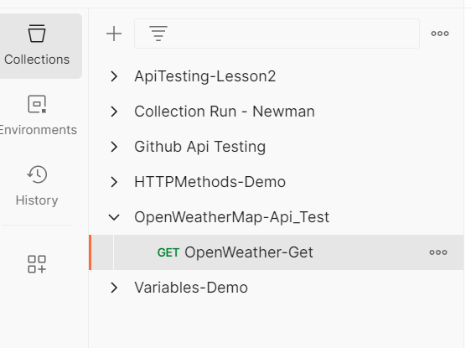

Step-15:

Then I click on “+” sign

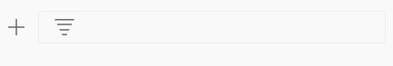

Step-16:

Then I rename it QA

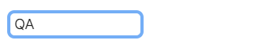

Step-17:

Then I give a variable name as city and value , save it

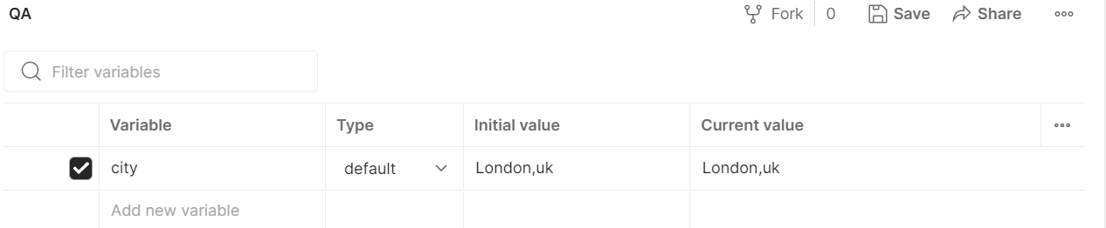

Step-18:

Then at right side click on environment and select my QA environment

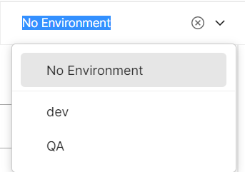

Step-19:Then I give city variable in request url

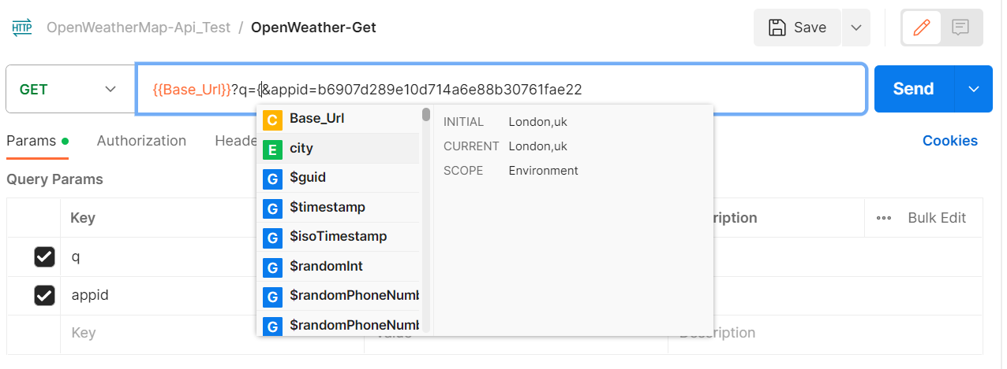

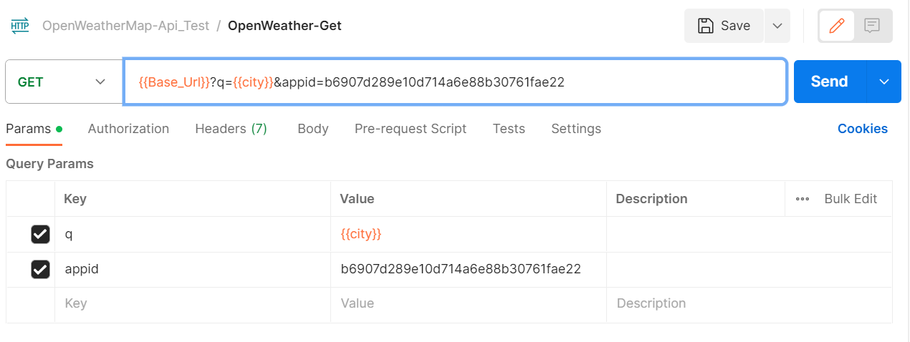

Step-20:

Then I create another variable in QA environment and save it

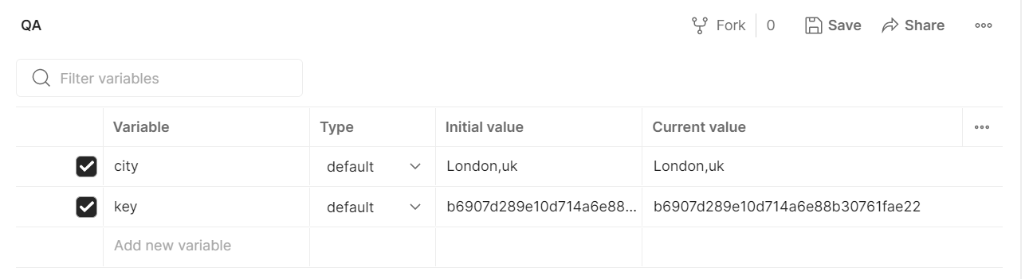

Step-21:

Then I select key in request url

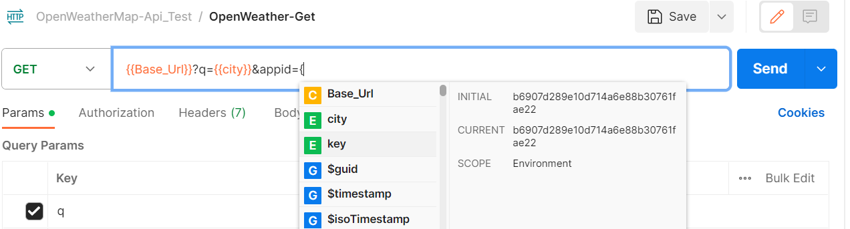

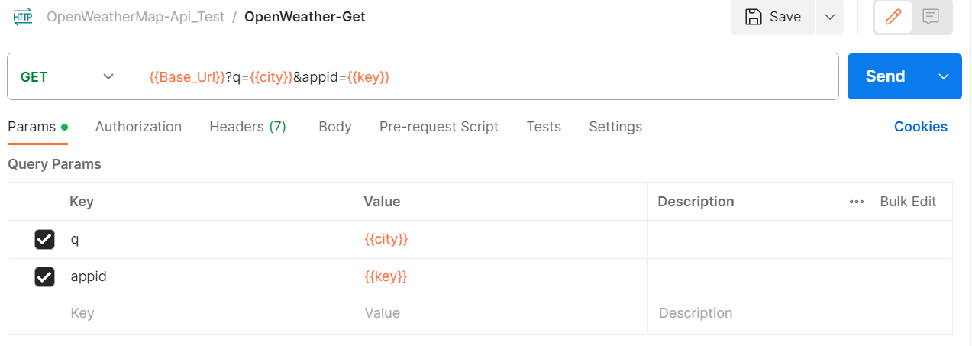

Result:

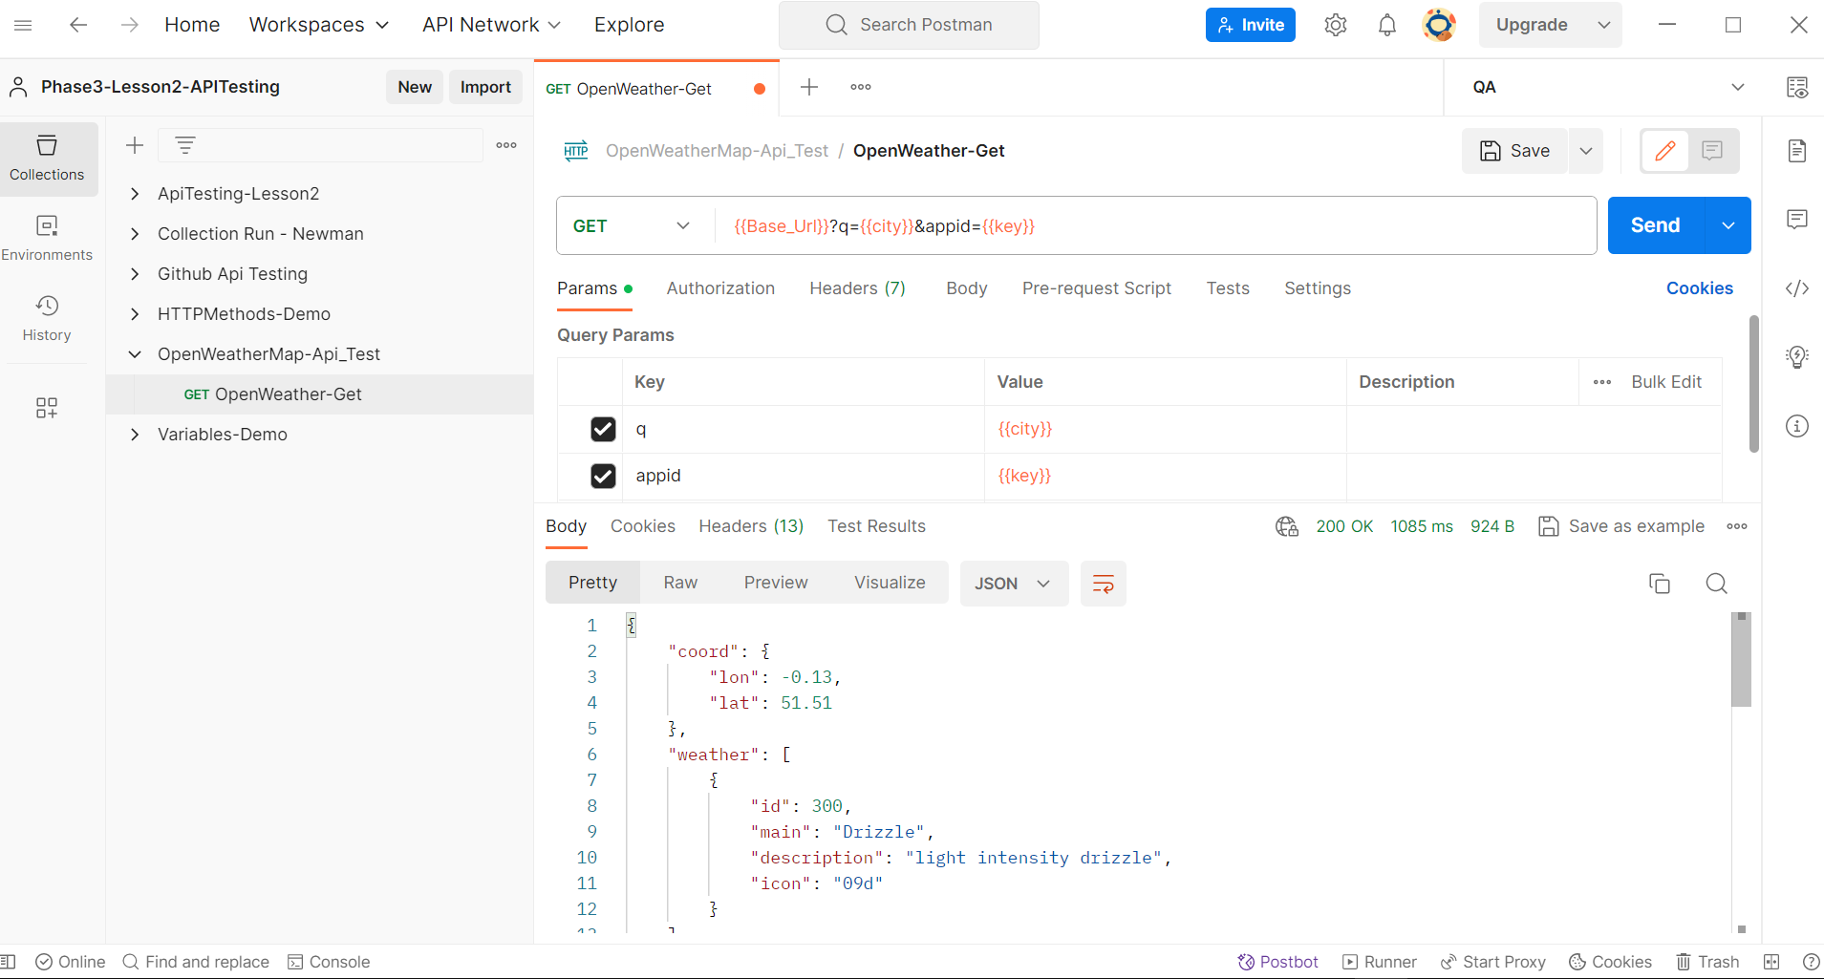

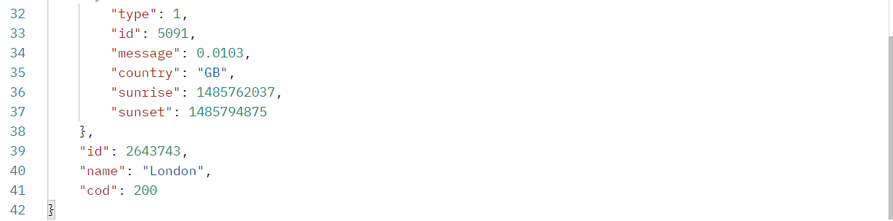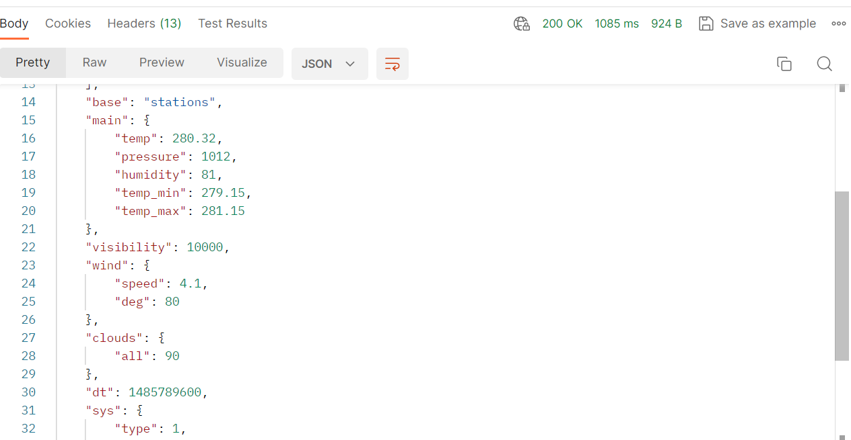

Step-22: Then I Export it

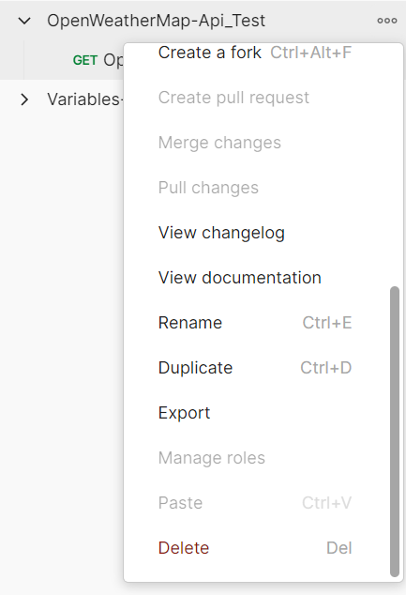

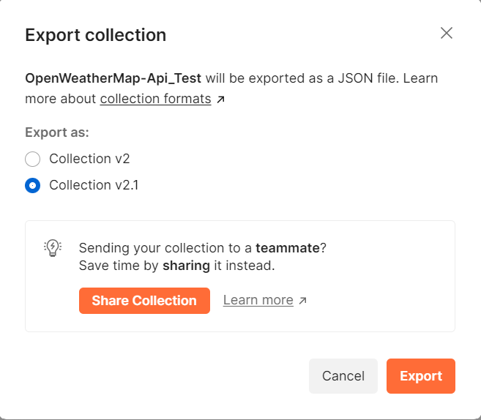

Step-23: Then I export QA environment

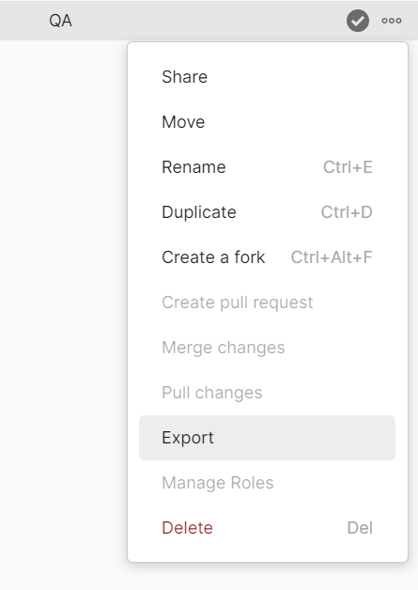

Step-24: Then I create a new github repository and pushed my project

